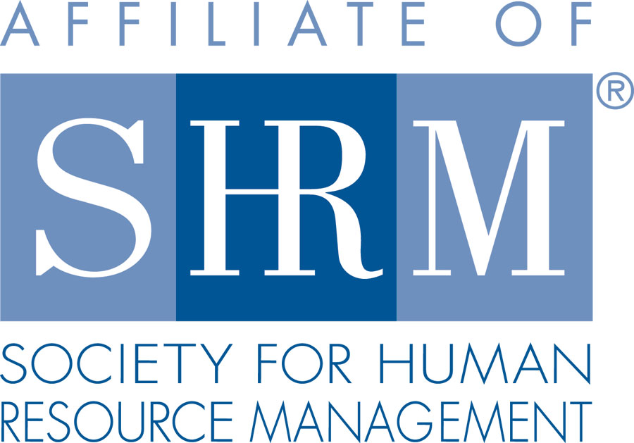

Membership Application
Member Information

Full Name: ________________________________________________________________ Date: ___________
Last First M.I.
Mailing
Address: _________________________________________________________________________________
Street Address Apartment/Unit #/Suite

_________________________________________________________________________________
City State Zip Code

Phone: (______) _______ - ________ Email Address: ______________________________________________

Alternate SHRM Certification
Phone: (______) _______ - ________ Membership #: ____________________ Designation: _________________
*Please note* this chapter is a 100% Chapter, therefore you must also be an active member of SHRM to join.

Company Name: __________________________________ Title: ____________________________________

On behalf of the Board, I would like to formally invite you to become a member of Skagit Island Human Resources Management Association, a SHRM affiliate. You qualify for this exclusive privilege based on your experience and commitment to the HR profession.
Our organization is an indispensable resource for Human Resource professionals throughout the region. Our members represent individuals who recognize the importance of our professional affiliation for staying current on HR changes and trends and networking. As a member, you’ll be able to continue your professional development, grow your contacts and collaborate with others with similar challenges.
We look forward to welcoming you to our chapter community.
Sincerely,
Laura Cowan
VP of Membership

Please scan and email this form to the Membership Chair, Laura Cowan:

lcowan12@outlook.com

