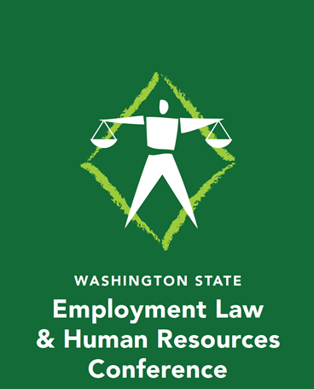
Register At: https://www.wastateshrm2019conference.org/
Washington State SHRM’s conference brings acclaimed employment law attorneys, national speakers and SHRM experts to the podium delivering powerful and impactful presentations on ever changing employment laws and legislative issues, as well as the role of HR practitioners and business leaders in these unique times.
Washington State Human Resources Council extends an invitation to join us in Seattle, Washington for Washington State Employment Law & Human Resources Conference. Please visit https://www.wastateshrm2019conference.org/ to see additional information and to register.
The Conference offers four tracks that cover Recruiting, Technology, Legal, and HR Generalist and a Senior HR Professional track. Other features include two pre-conference webinars and three keynote speakers.
To provide Washington State SHRM Members with content that delivers professional development and continued support of excellence in Human Resources; each of the sessions including preconference webinars will be pre-approved for both SHRM CP/SCP professional development credits and HRCI recertification credits.
Attendees can also request Legal CLE’s by providing their Washington State Bar number at registration.
Questions? Email wastateshrmevents@gmail.com
https://www.facebook.com/WASHRC/

