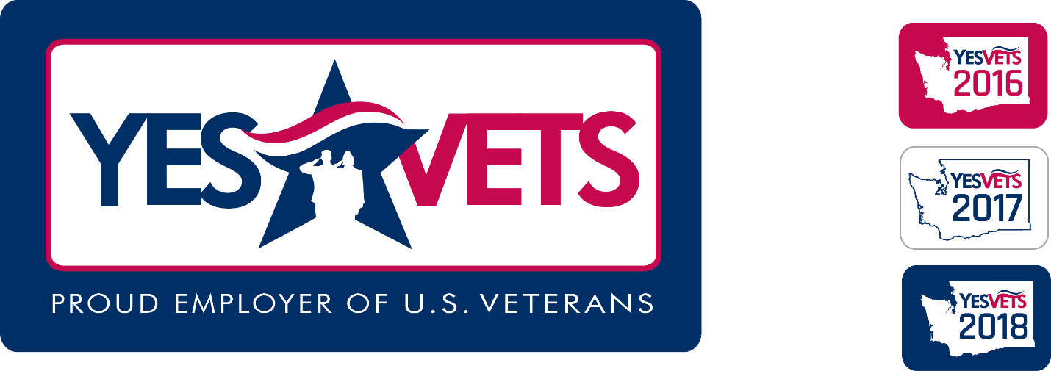

In March 2018, Washington State SHRM was proud to become a partner with YesVets and their other partner agencies (Employment Security Department, Washington Department of Veterans Affairs, Department of Commerce, and Washington State Military Transition Council). As affiliates of the Washington State SHRM, all Washington State SHRM chapters (15) are also included in the partnership as YesVets Ambassadors.
We know that hiring veterans is not just good for our country and not just a way to repay them for their service, it is simply, GOOD FOR BUSINESS. Military personnel have learned multiple skills and are experienced in transitioning to and from various tasks and responsibilities. They are a skilled talent pool ready and able to work. Help us increase the number of veteran hires in our state.
As of October 4, 2018, the 3,000th veteran was hired and there are now 778 participating YesVets employers. We encourage all businesses to become a YesVets employers and continue hiring veterans.
You can get additional information about the YesVets program by clicking on the following link: www.yesvets.org.

YesVets has made it easy for employers to participate; Simply click on the buttons below:
If you are an employer who has hired a veteran on or after January 1, 2017, select the, I want to participate button to provide some basic details about your company.
Then each time you hire a veteran, select the I Hired a Veteran button to complete the new-hire details.
Or if you would like to hire a veteran and would like to connect with your Local Veterans Employment Representative, select the I want to hire a veteran button.

